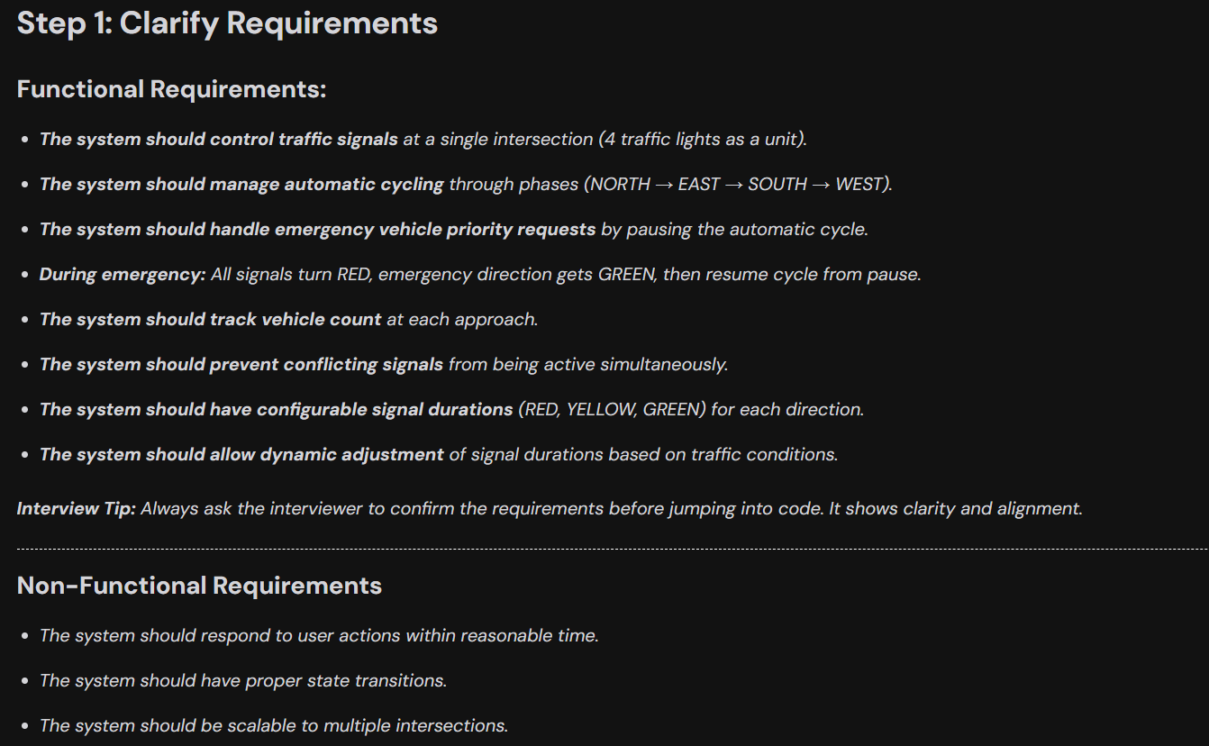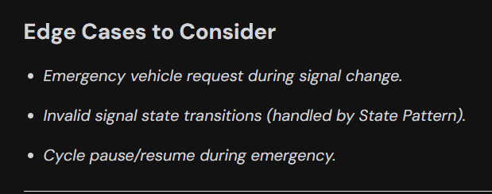

Flow

Every Intersection have 4 direction NSEW and one intersection would have vehicle count

**API Start → Get Intersection Config → Direction: North**

**Green Timer → Yellow Timer → Red Timer → Next Direction: East**

**Green Timer → Yellow Timer → Red Timer → Next Direction: South**

**...**

**Repeat cycle**

**Entities**

